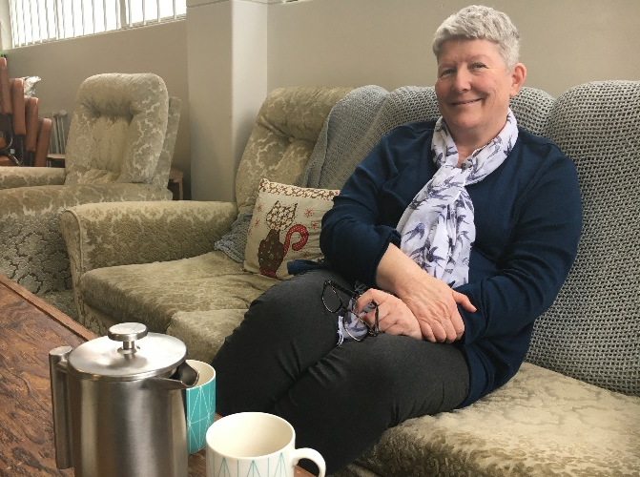
Wendy Hill, Supporter of pregnant women: Making pregnancy a path people can take
Wendy Hill is a counsellor, social worker and advocate. She’s also manager of Greenstone Doors in the Hutt Valley, which offers a safe and welcoming place for pregnant women and families.
“We’re here to make pregnancy possible,” Wendy says, “so that pregnancy is a path people can take.”
Women who approach Greenstone Doors for a pregnancy test and conversation are often just in need of a safe place for conversation. Barriers to continuing with a pregnancy often include being able to access government and community support, and overcoming reactions from others.
“The biggest barrier is people’s judgements – that they are pregnant again, or that they’re pregnant young or pregnant old. Just the judgements from society, that when you have a pregnancy it’s considered wrong, that you’ve somehow made a mistake.
“They don’t get that type of response here. They are welcomed in and everything possible is done to help keep the baby. We can’t make all the problems go away, but we can least support them.”
Wendy says sometimes pregnant women are afraid to tell people close to them that they are pregnant. Sometimes they are in bad relationships or living in difficult situations like a house full of alcohol.
“People need a sense of safety when they are pregnant. They are very vulnerable, but it is safe here. We’ve got a nurturing environment where there’s hospitality. But most of all they can build a trusted relationship with someone who does genuinely care, which they might not have on the outside.”
Sometimes women are vulnerable in pregnancy because of a previous loss, whether due to stillbirth, abortion or miscarriage. That can lead to great anxiety about a subsequent pregnancy, with many dealing with grief and feelings of unworthness.
“For any type of healing, there has to be a trusted relationship somewhere with someone. Pregnancy is such a tapu time for women, it’s such a sacred time. When you’re with a woman to do a pregnancy test, it’s not just the test, it’s everything that’s come before that.
“So journeying through a pregnancy that’s worrying for different reasons, it’s important that they don’t journey alone. We walk alongside, that’s what we’re asked to do as Christians, walk alongside people.”
Unfortunately, Churches are one of the places where pregnant women can experience judgement. “The Church really needs to get our language right, to bring the gentleness of compassion to how we approach this.”
Wendy says sometimes it’s tempting to want to “fix” a person’s life, to whip a pregnant woman off to the doctor to get checked out or to deal with other aspects of their life. But often that’s not what they want.
“They just want someone to sit with them in that moment, just to be with them. It’s as simple as that, just to be with them.The gift of time is so precious, to be just able to sit with people. Time which we often don’t have, do we?
“If we are able to slow down a person, just sitting here, if we can slow down a pregnancy in that way, then it becomes meaningful to them. It isn’t something that’s just disposable and can be gone in a moment. The gift of time is very precious.”
Wendy brings a lot of life experience as well as professional skills to her work for Greenstone Doors, which she knows is work God intended her to do.
“I’ve been a single parent. I lost my partner when I was pregnant. I’ve had the looks of judgement of having a lot of kids, of people saying, ‘Ooh, what does your husband do, he must have a good job’ and having to say, ‘I’m alone’. I know the walks that people have.”
Wendy says she’s learned the importance of conversations and relationships, and believes we have a duty of care towards each other.
“As Christians, that is our responsibility to see what we can do to make things right. I like to think I’m there for people. If somebody needs a listening ear, I’m here.”

